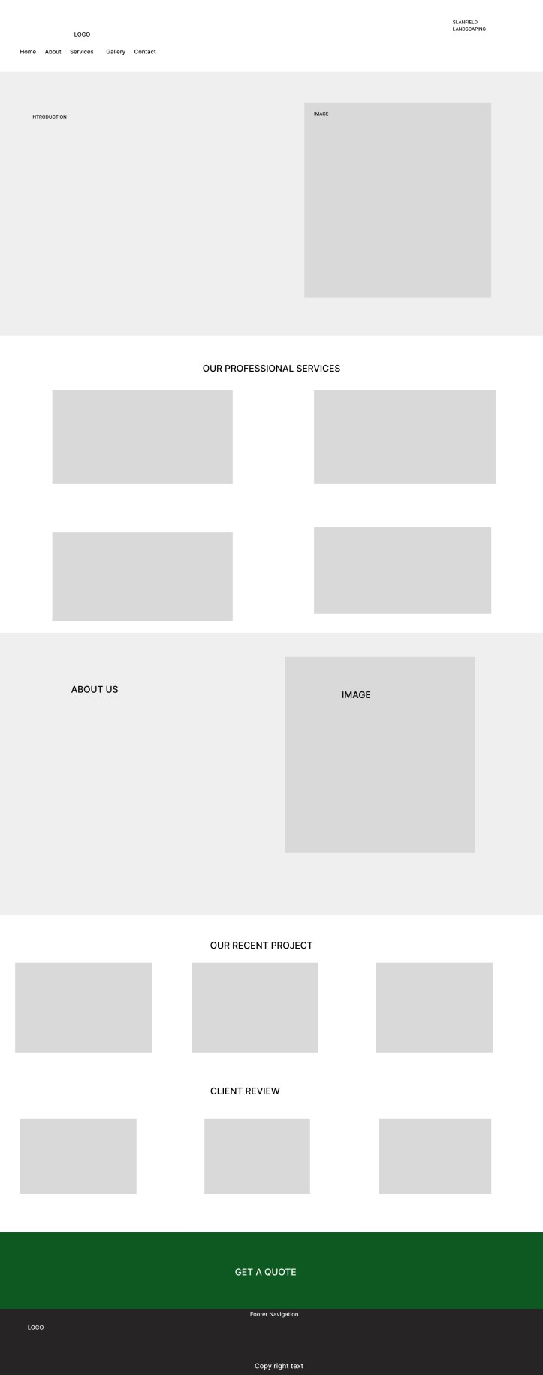
PAGE TEMPLATE

HOME PAGE TEMPLATE

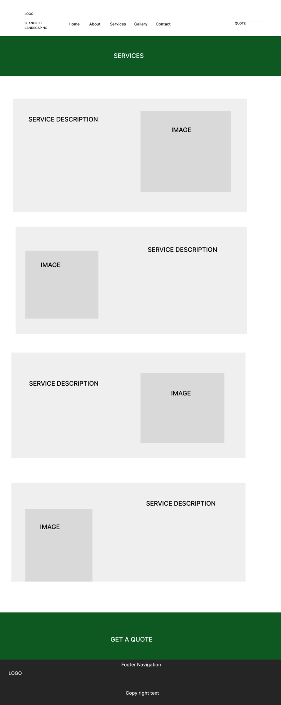

SERVICES PAGE TEMPLATE

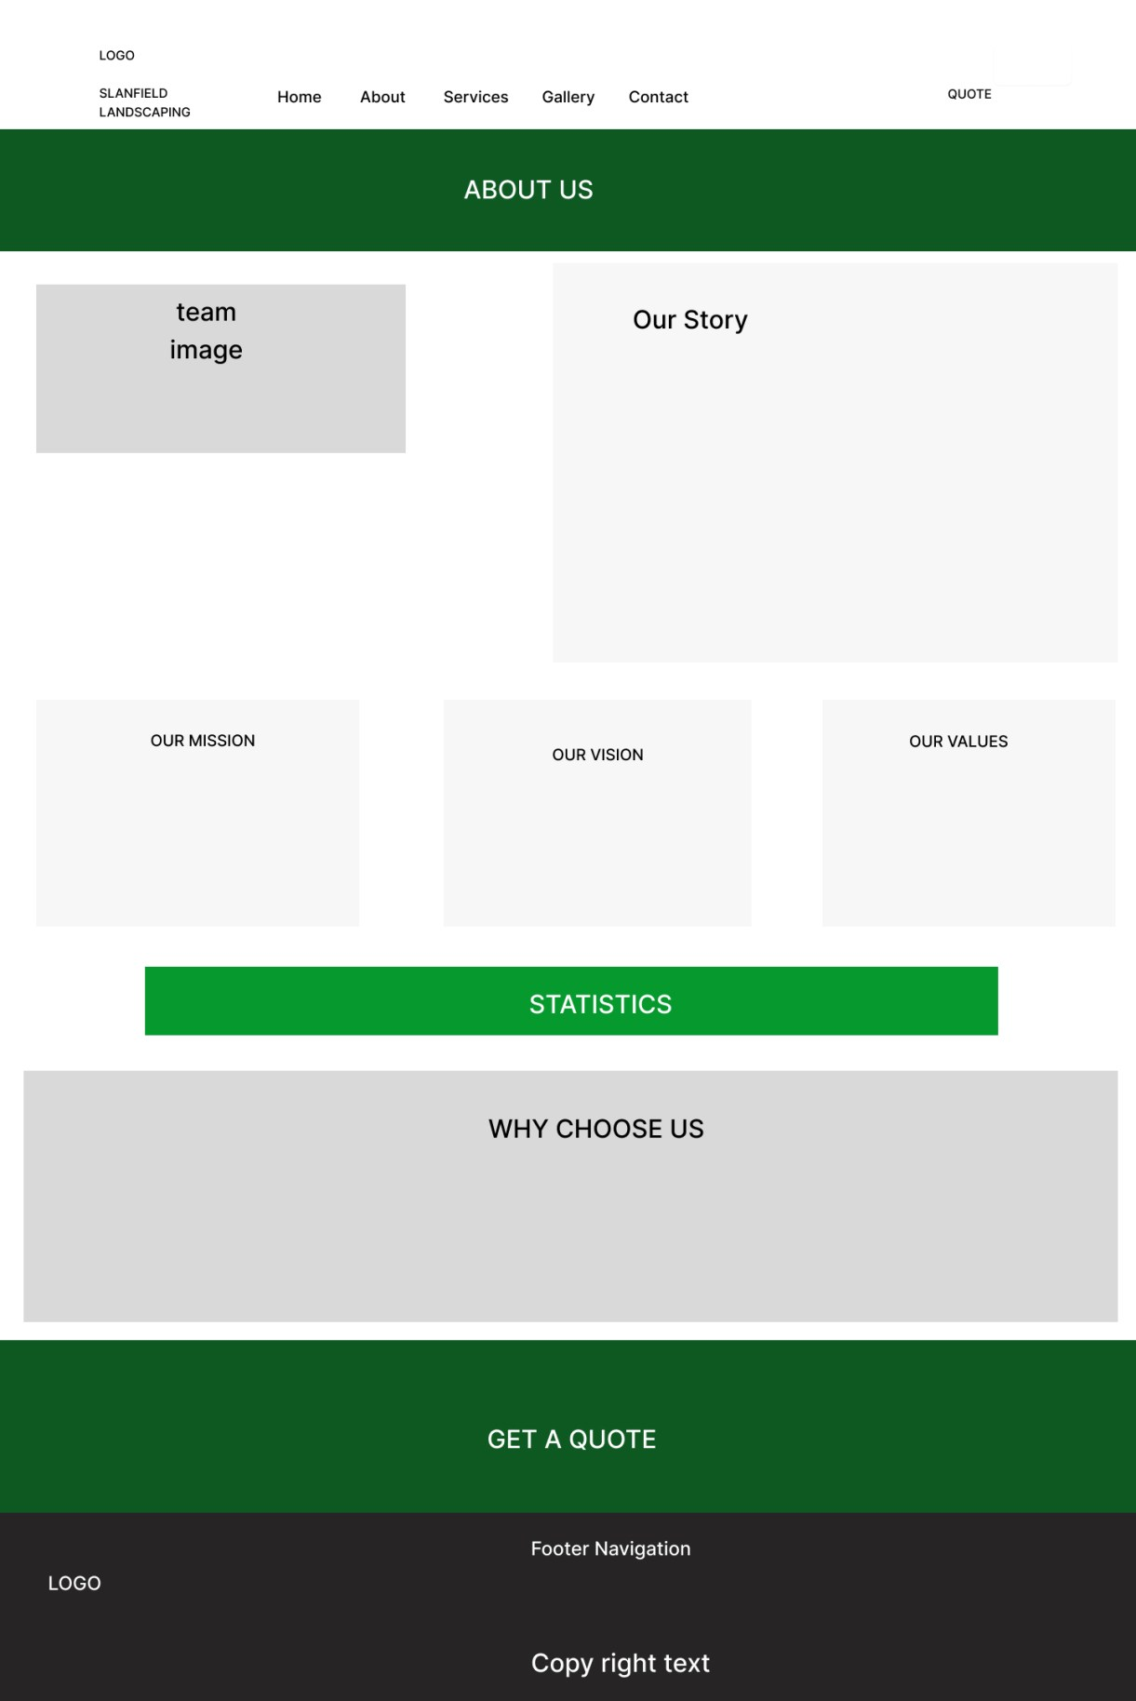
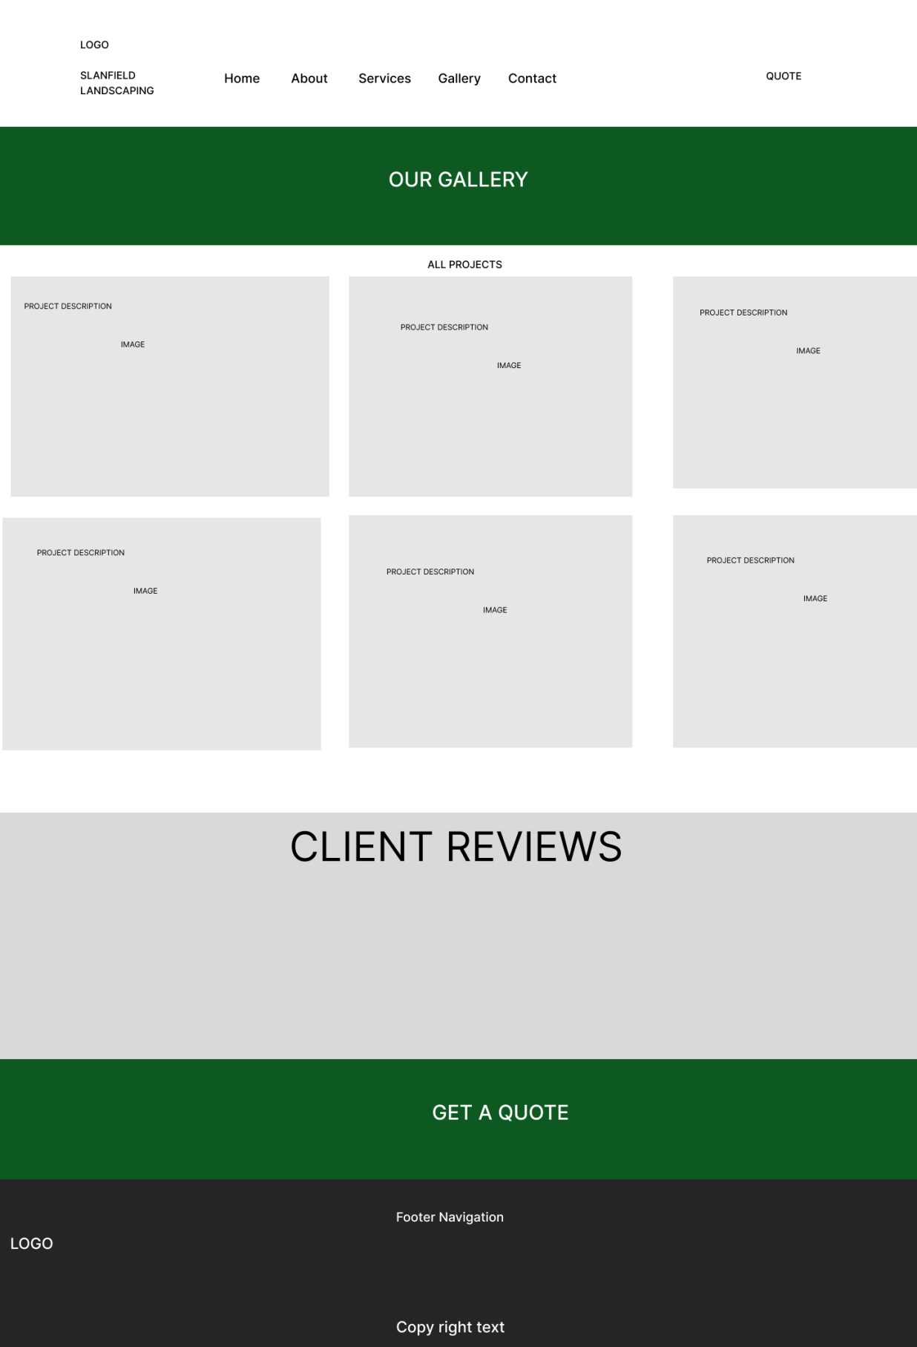

GALLERY PAGE TEMPLATE

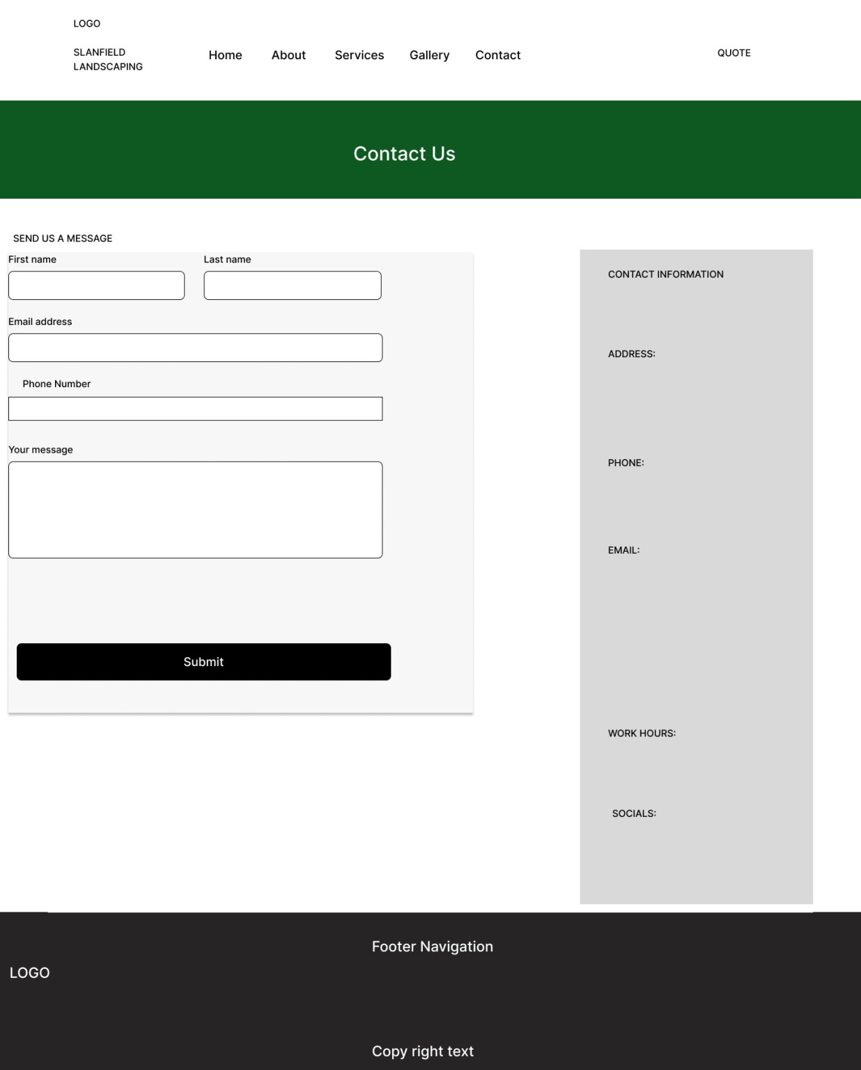

CONTACT PAGE TEMPLATE

